Needs Assessment Preliminary Report

for AIM

October 30, 2011

Table of Contents

Introduction
TOTS
- Objectives
- Targets
- Strategies
- Tactics
Observations
Findings
- Case Studies
- Quantitative/Qualitative Data Report (PPT)
Recommendations
Purpose and Design of Pilot Project
Pilot Project Options
Proposed Schedule
Agenda for Designing the 21st Century Classroom
Multiple Literacies for the 21st Century
21st Century Skills
Critical Attributes of 21st Century Education
20th vs. 21st Century Classrooms
Costs for Pilot Project
Thought Sparkers
Calendar

Introduction
It is imperative that the Malaysian government invest in sectors that will make Malaysia competitive in all world markets. One of these sectors, the foundation of all others, is the education sector. Without a high quality, 21st century education, Malaysian students will not be able to meet the Malaysian government’s goals of Innovation, Entrepreneurship and Human Capital.
According to Dr. Kamal Jit Singh “The Malaysian experience shows that our education system has largely replaced thinking with the regurgitation of facts and information. Schools impart information, not how to use the information to create a better society and world for us all.”
How will we create schools for the 21st century?
From Pre-K to Ph.D. — Project-Based Learning
Many educators, faced with the demands placed on them by standardized testing feel that projects are a luxury for which there is no time. Some educators seem to think that project-based learning is just for younger children, and by the time you get to the middle schools and high schools projects have all but disappeared. Read what Pete Border, physics professor at the University of Minnesota, has to say about project-based learning:
My department (physics at the U of MN) uses PBL for the students it really cares about, which is to say senior grad students working on their Ph.D.’s. Ph.D. candidates are the students the Department has decided to educate as well as possible regardless of cost, and the education they receive is entirely based on apprenticeships, designing and solving projects, long conversations, extended relationships and mentoring. Advisors guide and consult, suggesting new avenues of research and listening as much as talking. This is what the Department does when it has decided to ignore cost, and to go for the finest education possible.
I find it very interesting that there are no tests, bubble-sheets, drills, skill-tests, lectures, worksheets or curriculum standards in the Ph.D. candidate program. Even my Department knows, at its heart, that the finest education comes from long, involved, projects, and this is the best way there is to educate people!
It is true that Ph.D. candidates are an extremely unusual lot, and are many sigma into the tails of all distributions, but it is interesting that the project-apprentice-mentor-PBL model is used by all Ph.D. programs I’ve ever heard of, and that it always has been… Could it be because it’s the model that really works?

A few examples:
· A kindergarten class spends a year researching and creating a project benefiting the local hospital emergency room.
· A second-grade classroom researches cystic fibrosis (a classmate has CF) and raises $1,200 in funds for cystic fibrosis research.
· High school students create and publish documentaries related to important social issues— women’s rights, the environment, sweatshops, and more!
· At the High School for Law Enforcement and Criminal Justice in Houston, Texas an interdisciplinary team of teachers designs an integrated unit on the theme of Gunfight at the OK Corral.
Project-based learning is real-world, relevant, rigorous and integrates the curriculum. A growing number of teachers would like to implement project-based, interdisciplinary, thematic units in their classrooms - but are unsure of how to begin. Knowing about some of the common misunderstandings regarding project-based learning can help.
Students can exceed the standards, learn at higher levels and experience the joy of learning by participating in the most 21st century project-based learning experience of all - a global, collaborative classrooms project. There are many taking place, but we believe that our developing project, Food and Culture, will provide teachers and students with the highest levels of relevance, rigor and real-world connections as well as integrating vital 21st century skills and literacies. We have outlined a number of themes or issues related to Food and Culture ranging from a variety of health issues to agriculture, climate change, environmental issues, economics, the United Nations, culture, architecture and waste management.
There is ample room for many competitions as well. This project incorporates literally any content standards in any discipline.
However, we will not mandate what projects the teachers design. Food and Culture is a possibility and provides an exciting variety of examples. These will lead teachers to ideas of their own.

Thinking Skills and Change
During the Needs Assessment meetings and school tours in September 2011 the focus was the development of Higher Order Thinking Skills (HOTS) which would enable students to become innovators and entrepreneurs. It was suggested by some that students should be taught specific thinking tools, beginning with Thinking Maps, and that the teaching and use of one tool over a one year period of time is sufficient. We strongly disagree with this approach.
Thinking tools alone cannot just be “plugged in” to the current structure of education in Malaysia and achieve the desired results. The context must change as well.
As long as classrooms remain teacher-centered and textbook/test-driven, students will not develop authentic thinking skills or any other 21st century skills. To change from teacher-centered to student-centered, and from memorization to thinking/designing/problem-solving/innovation/entrepreneurship, etc., it is imperative that teachers are taught how to make the transition and how to help their students become self-directed, independent and interdependent as well as creative, collaborative, critical thinkers.

Here’s a Thought Sparker: you can’t leap a 20-foot chasm in two 10-foot jumps.
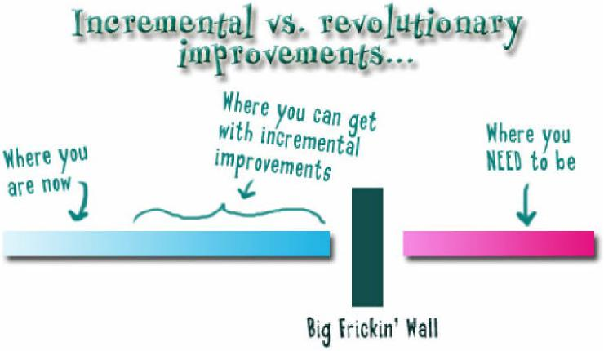

Change is not only possible, it is required. The following recommendations will result in the desired change.

Differentiated Professional Development
The recommended program of professional development can and will be modified to meet the learning needs of the teachers; it is no different in professional development for teachers than it is when teaching a classroom of students – individuals by human nature will be at various levels of understanding, knowledge and skill. It is our job to meet them where they are so that they can access prior knowledge and experience, connect it to new learning, and then invite them to the next level. This is Lev Vygotsky’s “zone of proximal development”. It is imperative, also, that the teachers receive substantial support during this process so that they will have the emotional security to take what they may perceive as risks.
While we are recommending the design and implementation of integrated, interdisciplinary projects, we also realize that some teachers will be at higher levels of understanding and enthusiasm than others. We will provide the teachers with a platform for transforming their classrooms into student-centered classrooms within their discipline – interdisciplinary projects are not required, although they are highly recommended. From our observations, we are confident that many teachers and students will eagerly embrace the opportunity presented.
The thinking tools discussed in our meetings, and which are the subject of Dr. Kamal’s articles, Tony Wagner’s 7 Survival Skills for the 21st Century, the 4Cs from P21, and the 21st century skills and literacies taught by us, 21st Century Schools, are completely embedded within the strategies we provide to the teachers for designing and implementing their lessons. Those specific thinking tools are taught in the workshop, Designing the 21st Century Classroom (see agenda below).

Immediate Results
One of the many classroom strategies we provide to teachers for having their students become self-directed, independent and interdependent can literally be applied in the classroom the day after the workshop!
As Dr. Kamal stated in his interview with Zakiah Koya, “Malaysians are particularly guilty of saying ‘It cannot be done’ when they mean ‘I don’t know how to do it, teach me.’”
It CAN be done; the teachers can and will make the change (some more rapidly and enthusiastically than others.) Our job is to show them how to make the change, and to support them through the process. Once they have begun, the students’ motivation will increase dramatically, the parents will see the results, and Malaysia will be on the way to the 21st century.
“The time has come for Malaysians to change – we do not have the luxury of time anymore – the world has changed.”
Think Positive, Have High Expectations and Don’t Sell Your Teachers and Students Short

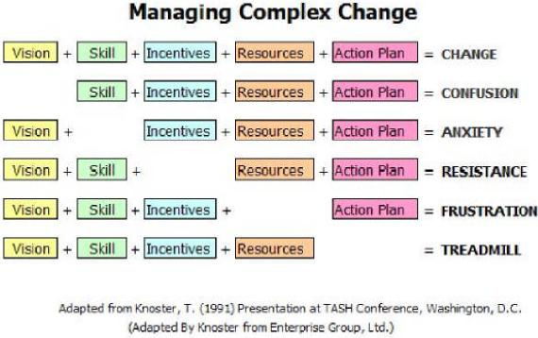

TOTS
Objectives – ultimate destinations.
- Create new-wave wealth for Malaysia using knowledge and brainpower.
- Improved lives for Malaysians – better living conditions, improved health, a progressive education system and a vibrant economy.
Targets related to the education system: (milestones to achieve by certain dates or that contain other criteria that is specific and can be measured)
- Develop 21st century skills in students, including but not limited to the 4Cs – Critical thinking, Communication, Collaboration and Creativity. See the list of the Seven Survival Skills for the 21st Century.
- Develop new methodologies for curriculum and instruction.
- Increase use of technologies for teaching and learning.
- Develop habits and skills for innovation and entrepreneurship among students.

Strategies – (overall intention providing guidelines for advancing towards the targets.)
- Create classrooms that are student-centered and which enable students to be self-directed, independent and interdependent learners.
- Educate/inform and gain the support of the Rayak. They must be enlisted as collaborators.
- Reinvent and align the education system- from teacher education to assessment to classroom curriculum and instruction.
- Provide access to current technologies and tools.
- Develop sources of support, from funding to collaborations among schools, industry, organizations, nonprofits, universities etc., not only in Malaysia but globally.
- Teachers and students learn and utilize thinking skills.
- Development of Multiple Literacies required for success in the 21st century.
- Removal of obstacles to change.

Tactics – (moment to moment actions required to meet the Strategies)
- Pilot Project with MoE and AIM
- Professional Staff Development for Educators
- Create 21st century modules/courseware
- Provide access to various technologies – tools and access to the Internet.
- Create common knowledge base and language among educators related to 21st century education.
- Sustained support of schools by MoE, AIM, industry, and the Rayak for educational change and excellence
- Develop sources of funding.
Observations
- Environment – designing and supporting 21st century schools begins with a conscious effort to create the proper environment. First, the physical environment. Second, the emotional environment. Finally, the academic environment.

  - The physical environment must be created to support a student-centered classroom. The classrooms we observed in Malaysia were unanimously teacher-centered, beginning with rows of desks facing the front of the room where the teacher stood, delivering/imparting knowledge to the passive students.

While most of the schools had wonderful courtyards, gardens and ponds, the classrooms were crowded, dark and in a general state of disrepair.

Resources were extremely limited.

One very powerful observation was the condition of the washrooms. These were shocking to us, and fact, the first time I (Anne) entered a washroom at a school I was so shocked that I took a photo. Then I deleted it from my camera because I did not wish to show this photo to AIM, MoE, the Task Force or the DG fearing that it would greatly embarrasses these people. Now I wish I had saved it.

Most of the students observed and interviewed seemed fairly happy, it was obvious, however, that they had concerns about the state of disrepair in their schools. The poor conditions and crowding of the classrooms, toilets and amounts of rubbish in and around the schools, as well as the poor quality of the canteens were all common topics of discussion. All of these factors directly affect the morale and attitudes of students.

As new schools are built they should have 21st century designs, and Malaysia should move away from the factory-model, obsolete buildings as quickly as possible. We have experts in school design who can assist in developing learning spaces for 21st century students; a 21st century smart school is much more than simply having wireless Internet access and technologies.

  - Emotional Environment – above all, schools should be happy, safe places. I agree fully with William Glasser, M.D. who said that “Learning is serious, but that doesn’t mean it has to be grim.”

Authentic learning involves the opportunity to try things and make mistakes. Learners must not live in mortal fear of making mistakes, nor should they be under pressure for taking meaningless standardized tests which measure nothing more than students’ ability to memorize facts.
A principal in a school where I taught used to place a motivational quote on the bulletin board in the teacher workroom every day. I’ll never forget one of them:
“The man who makes no mistakes makes nothing.”

  - Academic Environment – If It Isn’t Good, It Isn’t Done
High level academic achievements occur when the proper physical and emotional environments are optimally designed and in place. Next on the list is High Expectations. We found expectations for students and teachers, overall, to be extremely low.
One of the schools we visited was MCKK, which was described to us as the preeminent school in Malaysia. Students, we were told, were hand-picked by the MoE, based heavily on their test scores. We observed two classrooms simultaneously. The class observed by Anne Shaw was a biology class, and the class began with a humorous skit performed by some students. This gave me hope. However, as the class continued I became more and more discouraged. It was extremely structured, low level, basic knowledge, no real thinking skills or challenges were apparent. As in most of the classes I observed in Malaysia, I took copious notes, writing as much as I could about what the teacher said, what students said, everything I could write that I saw and heard. I finally became so discouraged after observing several highly structured, low level “experiments” that I wrote “rinse and repeat”. (Those are directions found on shampoo bottles in the USA). In other words, it was a series of uninspiring, highly structured activities again and again.

Findings
- Case Studies - videos and analysis of classrooms observed
- Quantitative/Qualitative Data Report (PPT)
- Analysis of Anecdotal Records from Classroom Observations and Meetings

Videos – please see this link

Recommendations
- Malaysian National Conference on 21st Century Education (organized by 21st Century Schools) – This conference will provide an environment for letting teachers know that they are respected as professionals, it provides an exciting and motivational introduction to education for the 21st century, it provides teachers with the critical opportunity to meet and learn from each other (sharing and generating new ideas and a sense of community), and finally, it will provide all Malaysian educators with a great deal of new knowledge.
We will design a conference with expert speakers representing all facets of 21st century education. We will also have small group workshops and presentations from teachers and students from various countries.

- Professional Staff Development – research has shown us that the countries with the highest performing students also spend a significant amount of time on professional development. This PD is provided in a variety of formats: conferences, on-site, attending outside workshops, professional learning communities and study groups, peer coaching, etc.

- School Class Schedules – the current schedule in schools is a major impediment to the desired changes. Thirty minute classes in primary school and forty minute classes in secondary school are obsolete in the 21st century. Although some classes have double periods we would like to work with the schools to create schedules that best support optimal learning, and optimal opportunities for high quality learning experiences.

Possibilities to consider are block schedules, career academies, smaller learning communities, schools within schools, and interdisciplinary grade level teams. Other options include internships, online learning, and early college high schools (a blend of high school and college in which students earn college credit up to a two-year associates’ degree.)

- Access to technology and online resources. Malaysian students were born into and will have to succeed (not merely survive) in a globalized society dependent upon technologies, the Internet, and rapid, constant change in the world. All schools should be connected to the Internet, and all schools should be wireless so that students can access the Internet as well as their files from anywhere on the school property. Additionally, this will reduce the cost of purchasing textbooks and workbooks, making information up-to-date literally by the minute.

Equipment such as tablet computers should be provided to all teachers and students. In addition to the benefits listed above, students will have access to Web 2.0 tools which are motivational but also support creativity, problem-solving, critical thinking and collaboration. The cost of a high quality tablet is actually less than the cost of multiple textbooks and other print resources which are usually out-of-date at the time of printing.
- Pilot Project Options – listed below you will find three suggested options, or possibilities, for proceeding with the Pilot Project. Any of these are modifiable.

- Proposed Schedule for Pilot Project – see below.

- Align teacher education with PreK-12 education.

- Release Teachers from Non-teaching Duties - Both financial and educational benefits will occur when teachers are released from non-teaching duties so they can focus on their real job – teaching and learning. Just two possibilities include hiring one or more people per school to take over the non-teaching duties. Another recommendation is streamlining the data collection and reporting systems, eliminating those tasks that are either redundant or not needed.

- Planning Periods for Teachers – teachers should be provided with a minimum of one hour per day uninterrupted planning time.

- School Visits – there are a number of excellent schools in the USA. A visit to these schools could be arranged.

- Modernize the washrooms at all schools.

- Funding - leadership should launch a major campaign to develop public/private partnerships, raise funds and in-kind support to introduce 21st Century Curriculum and Instruction, provide staff development into Malaysian schools efficiently and effectively. For example, the State of California has done this for an environmental studies project. The overall project need is estimated at $22 million over four years to cover outreach, printing and distribution, teacher training, evaluation and building long-term sustainability. (This funding is for development of an environmental studies curriculum only.)

Purpose and Design of the Pilot Project will need to be designed down (or backwards) from the ultimate goal, and planning the Pilot Project will be guided by the following questions:
- What is it that we want teachers and students to know, be able to do and to be like as a result of this pilot project?

- What concepts and/or skills are we helping students, teachers and parents to develop?

- What experiences can we provide to teachers and students which will enable them to develop these concepts and learn these skills?

- How will we know that the teachers and students have accomplished these goals?

Pilot Project Options
A three-month pilot project is planned to take place January through March of 2012. The current idea is to include 24 schools at all grade levels. This will necessitate the provision of professional development for approximately 800 teachers as well as ongoing on-site and online support and evaluation of classrooms in all 24 schools.
The purpose of the project is to demonstrate how education can be revamped in Malaysia in order to develop students’ thinking skills and to develop their skills as entrepreneurs and innovators. Students will need to learn thinking skills as well as learn how to become self-directed, independent and interdependent. This will require a shift from a teacher-centered classroom to a student-centered classroom.
This transition can be accomplished by teaching the teachers and the students specific tools. Teachers will have to learn new ways to organize their classrooms and new ways to design and deliver their lessons. They will need to learn to utilize authentic assessments. Students will have to be taught how to be self-directed, independent and interdependent. They will also have to be provided with tools for various types of thinking.

Possibilities/Recommendations for the Pilot Project
The pilot project can focus on one or both of the following items, each of which is possible within the constraints of the time provided – a three-month pilot project to begin in January of 2012.
- Web 2.0 Tools – students will utilize several Web 2.0 tools which will serve as the platform for research, collaboration (among their classmates as well as collaboration with students in other states or countries), critical thinking, creativity, problem-solving and innovation, 21st century skills and multiple literacies. These tools will also enable students to become self-directed, independent and interdependent.

- Mini-project – teachers will plan and implement a project to take place over a period of 2-6 weeks. This project will incorporate the development of skills required for success in the 21st century, including, but not limited to, specific thinking tools.

Implementation of the Pilot Project

- Professional Development – Professional development will be provided prior to actual implementation of the pilot project in the schools. Please see the agenda for the workshop, Designing the 21st Century Classroom below. This workshop agenda is an example of designing down, or designing backwards from the desired outcomes.

- Implementation in the Classrooms- Ongoing support and assessment during the pilot project.

- Evaluation – pre, post, and ongoing evaluations.

Option I – all teachers, 24 schools, 6 consultants, 6 months

Option II – teachers for 2 grade levels, 24 schools, ____ consultants (depends upon number of teachers – 1 consultant per 25 teachers), 5 months estimate

Option III - 6 schools – all teachers; 18 schools – develop knowledge base through expert study groups, then enter next round of professional development to expand upon what was done in the first 6 schools.

Option IV - incorporate virtual learning. This can be done in a number of ways, from live, online professional development (with or without video) to the use of collaborative online tools to the production of professional development videos which the teachers can access any time and as many times as they choose.
We recommend a "blended learning" experience, which is a combination of on-site and online learning.

Pilot Project Proposed Schedule – Option I – the following schedule depends upon the availability of our consultants on a very short notice, as well as consideration of their current duties.
Now to November 1 –
- Finalize contract between AIM and 21st Century Schools for Phase II, the Pilot Project.
- Finalize location and date of professional development for each school.
- Finalize consultants to provide training, ongoing support and evaluations
- Finalize consultants’ schedules
- Arrange for waivers from regular school schedule as needed in participating schools
- Arrange for relieving participating teachers from duties other than teaching and learning. Arrange for at least 1 hour per day for lesson planning for each teacher.
- Plan professional development details, then have necessary materials printed, and necessary technology tools in place, including access to Internet.
- Generate support among parents and the communities through media as well as regional introductory meetings. Bring them on board!
- Arrange for support from MoE, industries, nonprofits, organizations, universities and the media.
November 7 – consultants travel to Malaysia, then have 2 days to rest from the journey.
November 10-11 – meetings among consultants and with AIM
November 12 -13 – consultants break;
November 13 – travel to site of first professional development session.
November 14 – begin professional development with teachers. 160 teachers per week receive 3-5 days of professional development, including time for developing lesson plans for the pilot project. Best ratio of consultants to teachers is 1:25 for optimal success. Five to six trainers needed for five weeks of training.
November 14 – December 16 – professional development for participating schools.
Teachers/schools will be organized into five groups; each group will receive one week of professional development in one location. So we will need five regional locations to which teachers will travel to attend the week of professional development. The facility should be able to provide space for whole group sessions as well as 5 simultaneous small group sessions.
Sleeping rooms should be provided for attending teachers as well as daily food/beverage services for a continental breakfast, mid-morning break, lunch and a mid-afternoon break. Workshops will run each day from 8:00 a.m. to no later than 4:00 p.m. Monday through Friday. Friday evening the consultants will travel to the next location, then have Saturday and Sunday for rest and preparation for the coming week.
Dec. 16 – January 2 – break for consultants
January 2 – March 31 – Pilot Project – consultants provide ongoing support on-site and online. Ongoing gathering of data on how project is progressing. Provide additional professional development as needed. Each consultant will be assigned to 4 schools and will visit these schools weekly to assess progress and provide support.
April 1-30 – Analyze data gathered during pilot project, including pre and post-assessments; report to MoE and AIM. Make recommendations for next steps based on results.

Agenda for

Designing the

21st Century Classroom

Note: this workshop incorporates the teaching of specific Thinking Tools in a section entitled Thinking Toolbox which is part of the Classroom Strategies section of the workshop. These specific thinking tools are then embedded in the curriculum units/projects/lesson plans. This outline is for a three-day workshop. We are recommending 3 days for this workshop plus an additional 2 days to assist teachers in developing the lesson plans for their classroom which will be incorporated into their classrooms in January. They will continue to refine these plans as they conduct research on available resources after the workshop. We will be available for assistance.
These units will be developed by the teachers in consideration of their individual constraints such as experience, openness to change, their schedules, etc.

Workshop Agenda

Goal: By the end of this three-day professional development experience the participants will have created the framework for a unit of curriculum designed specifically for their classroom and which incorporates the needs of their particular students and the resources of the local community. This curriculum will be based upon their investigation of authentic education in the 21st century.
Description: Participants will spend two days working collaboratively as they examine critical attributes of the 21st century and then apply their findings to the development of curriculum and instruction. Throughout the two days participants will be actively involved in a variety of activities, groups and presentations. They will not just hear about, but will experience, the 21st century classroom!
Sessions in which participants will be working collaboratively and/or are involved in activities are marked with (P) at the end of the description of that section. Very in-depth sessions are marked with ***.
Introduction – participants will review the goals and agenda for the two-day workshop:
The 21st Century – participants will examine and analyze critical attributes of the 21st century, from demographic changes to the technological revolution, our media culture and more.
The Purpose of Schooling – a review of how and why curriculum and instruction were designed and delivered for the 20th century and identification of changes required in the 21st century.
Multiple Literacies for the 21st Century – participants become familiar with the variety of literacies required for successful participation in the society of the 21st century, including visual literacy, aural literacy, cyber literacy, ecoliteracy, financial literacy, multiple media literacies and more. (P)
Restructuring Schooling in the 21st Century – redefining of “learner”, “teacher” and “school”; characteristics of 21st century schools.
The Global Classroom - here participants will examine the characteristics of the global classroom, and will be presented with specific strategies to take their classroom global – literally. They will receive a list of excellent resources for connecting with classroom projects or individual classrooms with whom to collaborate all over the world. They will examine the potential of the use of the Internet and email, but also be aware of many other means by which to take their classroom global if the technology is not available.

*** The 21st Century Classroom - what to look for in a classroom. What is a quality classroom in the 21st century? Participants will be presented with characteristics of a quality classroom as well as specific steps to take in creating/designing a quality classroom for the 21st century. These include designing the physical environment, the emotional environment, academic expectations, and an in-depth examination of classroom management, organizational and learning strategies.
*** Web 2.0 Tools – small groups will create products using various Web 2.0 tools. Use of these tools will be incorporated into their project-based unit design framework.
*** Designing Curriculum for the 21st Century Classroom – this session will include overviews of several sample units of curriculum. Participants will analyze these units, then design units for their classroom using tools provided in this session and incorporating the information and strategies learned in previous sessions. Participants will work collaboratively in grade-level groups to design an actual unit for their classroom. (P)
Culmination - Participants will present and explain their unit design to the whole group. (P)

Workshop Goals for Designing the 21st Century Classroom
Overall Goal - by the end of this three-day workshop the participant will have created a framework for a thematic, interdisciplinary, project-based unit of curriculum designed for the 21st century classroom.

In order to achieve this objective, the following goals, or outcomes, will be met during the three days:
Outcome #1 – 21st Century Schools and Classrooms - Investigate and identify critical attributes of the 21st century classroom and school. Discover structures for supporting the 21st century classroom.

Outcome #2 - Classroom Strategies - Identify specific practices and classroom structures which support the 21st century classroom.
Outcome #3 – Web 2.0 Tools – create products using a variety of Web 2.0 tools.

Outcome #4 – Unit Design - Create framework for a thematic, interdisciplinary, project-based unit of curriculum incorporating critical attributes of the 21st century classroom which will incorporate classroom strategies, thinking tools, Web 2.0 tools, 21st century skills and content standards.

Designing the 21st Century Classroom

Workshop Goal - Participants will design a framework for a thematic, interdisciplinary, project-based unit of curriculum.

Outcome 1 – 21st Century Classrooms and Schools | Investigate and identify critical attributes of the 21st century classroom and school. Discover structures for supporting the 21st century classroom.
DO: | BY/WITH:
Identify critical attributes of the 21st century | Think/Pair/Share and Whole Group Discussion– brainstorm and discuss critical attributes of the 21st century, comparing them to 20th century, then discuss what these differences mean for education.  Some facilitator presentation/overview.
Define – “Teacher”, “Learner” and “School” | Identify traditional definitions, then look at new definitions for the 21st century.
Examine multiple literacies required for the 21st century. | Expert Groups –  - Visual Literacy  - Aural Literacy  - Financial Literacy  - Ecoliteracy  - Media Literacy  - Information Literacy  - Cyberliteracy  - Emotional Literacy  - Multicultural Literacy  - Global Competencies/Literacies  Jigsaw – Experts now share the results of their Expert Group discussion, then creates a synthesis of the results. What literacies are important today?
Say, Look What They’re Doing! | Analyze videos of example classrooms in action.
Examine models of 21st century schools in order to determine common characteristics. | Expert Groups – examine example of a particular school, looking for evidence of 21st century characteristics.  Jigsaw - Experts share the results of the Expert Group discussion, then the Jigsaw Group creates a synthesis of the results. What are the critical attributes of a 21st century school?
ENABLERS: | STRATEGIES:
Vocabulary – literacy, multiple literacies, media literacy, critical attributes, investigate, consensus and negotiation, synthesis.  Learning Pyramid  Bloom ‘s Taxonomy | Expert Groups and Group Process  Jigsaw process  Think/Pair/Share  Consensus building  Negotiation  Roles - Organize, Guide and Help, Critique, Negotiate
GROUP ASSESSMENT: | INDIVIDUAL ASSESSMENT:
Facilitator and Participant observation and discussion.  Presentations to whole group. | Participant and Facilitator observation of:  Individual participation  Products created in each activity

Outcome 2 – Classroom Strategies | Identify specific practices and classroom structures which support the 21st century classroom.
Review some classroom strategies for creating the 21st century classroom. | Whole Group – facilitator presentation.
Learn classroom strategies to support the 21st century classroom by helping students to become self-directed, independent and interdependent learners. | Create-a-Story activity – individually. Participants will participate in this activity designed to get the students started on self-directed, independent and interdependent learning practices.  After the activity is completed, the whole group will identify the level of thinking used in each phase of the activity.
ENABLERS | STRATEGIES
Bloom’s Taxonomy | Create-a-Story
GROUP ASSESSMENT | INDIVIDUAL ASSESSMENT
Whole group and facilitator observation. | Individual results of the Create-a-Story activity.  Whole group discussion.

Outcome 3 - Web 2.0 | Create a number of products utilizing Web 2.0 tools
Introduce a number of Web 2.0 tools | Whole Group – facilitator presentation/introduction to Web 2.0 tools.
Participants create a product using a Web 2.0 tool; content may be negotiated. | Expert Groups –  - Glogster  - VoiceThread  - Weebly  - Wix
Identify 21st century skills used during the process of creating the products. | Whole Group Discussion
ENABLERS | STRATEGIES
Introduction to variety of Web 2.0 tools | Expert Groups
GROUP ASSESSMENT | INDIVIDUAL ASSESSMENT
Presentation of product.  Final reflection. | Participation in group process.

Outcome 4 - Unit Design | Create framework for thematic, interdisciplinary, project-based unit of curriculum incorporating critical attributes of the 21st century classroom.
Review general process for designing a unit of curriculum for the 21st century classroom. | Whole Group – facilitator presentation/introduction to unit design.
Examine possible themes for units. | Whole Group – facilitator presentation.
Review critical attributes of unit. | Whole Group - facilitator presentation.
Design unit framework | Small Groups - participants will now apply their knowledge of the 21st century classroom and unit writing procedures by creating a unit framework in the theme of their choice.
Standards | Small groups now review the state standards for their courses to identify which ones may be taught within their unit design.
ENABLERS | STRATEGIES
Application of knowledge obtained in previous activities – critical attributes of the 21st century and 21st century schools; classroom strategies; Web 2.0 Tools; Multiple Literacies; unit design process. | Unit Design Rubric  Group Process
GROUP ASSESSMENT | INDIVIDUAL ASSESSMENT
Presentation of unit design/framework.  Unit Design Rubric | Participation in group process.

Multiple Literacies for the 21st Century
According to Douglas Kellner, Ph.D. at UCLA “literacy involves gaining the skills and knowledge to read and interpret the text of the world and to successfully navigate its challenges, conflicts and crises. Literacy is a necessary condition to equip people to participate in the local, national and global economy, culture and polity.”
This is a list of important literacies which should be developed through 21st century curriculum.
- Ecoliteracy
- Financial Literacy
- Media Literacy
- Emotional Literacy
- Information Literacy
- Aural Literacy
- Visual Literacy
- Multicultural Literacy
- Physical Fitness and Nutrition
- Cyberliteracy
- Global Competencies

Seven Survival Skills for the 21st Century.
After interviewing hundreds of CEOS in business, non-profits and educational institutions Tony Wagner of Harvard University identified the top seven survival skills needed for the 21st century in his book The Global Achievement Gap.
1. Critical Thinking and Problem Solving
"The idea that a company's senior leaders have all the answers and can solve problems by themselves has gone completely by the wayside...The person who's close to the work has to have strong analytic skills. You have to be rigorous: test your assumptions, don't take things at face value, don't go in with preconceived ideas that you're trying to prove." - Ellen Kumata, consultant to Fortune 200 companies

2. Collaboration Across Networks and Leading by Influence
"The biggest problem we have in the company as a whole is finding people capable of exerting leadership across the board...Our mantra is that you lead by influence, rather than authority." - Mark Chandler, Senior Vice President and General Counsel at Cisco

3. Agility and Adaptability
"I've been here four years, and we've done fundamental reorganization every year because of changes in the business...I can guarantee the job I hire someone to do will change or may not exist in the future, so this is why adaptability and learning skills are more important than technical skills." - Clay Parker, President of Chemical Management Division of BOC Edwards

4. Initiative and Entrepreneurship
"For our production and crafts staff, the hourly workers, we need self-directed people...who can find creative solutions to some very tough, challenging problems."- Mark Maddox, Human Resources Manager at Unilever Foods North America

5. Effective Oral and Written Communication
"The biggest skill people are missing is the ability to communicate: both written and oral presentations. It's a huge problem for us." - Annmarie Neal, Vice President for Talent Management at Cisco Systems

6. Accessing and Analyzing Information
"There is so much information available that it is almost too much, and if people aren't prepared to process the information effectively, it almost freezes them in their steps." - Mike Summers, Vice President for Global Talent Management at Dell

7. Curiosity and Imagination
"Our old idea is that work is defined by employers and that employees have to do whatever the employer wants...but actually, you would like him to come up with an interpretation that you like-he's adding something personal-a creative element." -Michael Jung, Senior Consultant at McKinsey and Company

Critical Attributes of 21st Century Education
- Interdisciplinary
- Project-based
- Research-oriented
- Expert Groups and Jigsaw (teams and collaboration)
- Thematic – what kinds of themes or issues?
- Student-centered
- Connections to community
- Global classroom
- Authentic assessment
  - Portfolios
  - Projects
  - Rubrics
  - Products (multimedia, etc.)
- Multimedia – as tool for learning and as a tool for assessment
- Multiple literacies
  - Aural literacy
  - Visual literacy
  - Emotional literacy
  - Financial literacy
  - Ecoliteracy
  - Cyberliteracy
  - Media literacy
  - Information literacy
  - Global Competencies
- Multiple Intelligences
- Student Diversity
- Service Learning
- Multiple technologies
- 21st Century Skills
  - Critical Thinking/Problem Solving
  - Collaboration/Leading by Influence
  - Agility and Adaptability
  - Initiative and Entrepreneurialism
  - Effective oral and written communication
  - Accessing and Analyzing Information
  - Curiosity and Imagination/Creativity
- Web 2.0 Tools
- Rigor, Relevance and Connections to the Real World

Which one describes your classroom or school?
The following table will be published by Pearson Publishing in January of 2012 in a higher education textbook. It will be published in all languages.
20th Century Classrooms 21st Century Classrooms
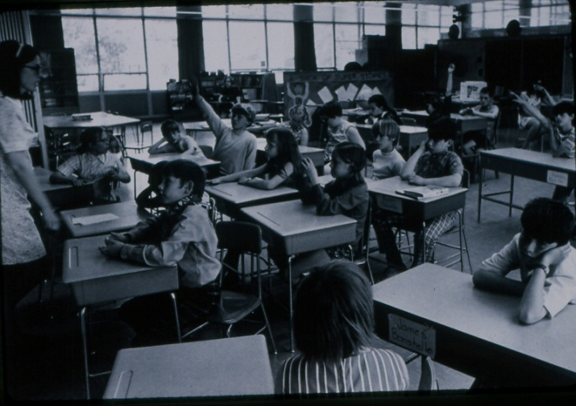  USA 1960’s typical classroom – teacher-centered, fragmented curriculum, students working in isolation, memorizing facts. | 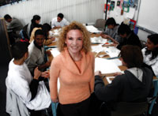  A San Francisco architectural firm establishes an alternative school providing internships for high school students. A perfect example of real-life, relevant, project-based 21st century education.
Time-based | Outcome-based
Focus: memorization of discrete facts | Focus: what students Know, Can Do and Are Like after all the details are forgotten.
Lessons focus on the lower level of Bloom’s Taxonomy – knowledge, comprehension and application. | Learning is designed on upper levels of Blooms’ – synthesis, analysis and evaluation (and include lower levels as curriculum is designed down from the top.)

Textbook-driven | Research-driven
Passive learning | Active Learning
Learners work in isolation – classroom within 4 walls | Learners work collaboratively with classmates and others around the world – the Global Classroom
Teacher-centered: teacher is center of attention and provider of information | Student-centered: teacher is facilitator/coach
Little to no student freedom | Great deal of student freedom
“Discipline problems – educators do not trust students and vice versa. No student motivation. | No “discipline problems” – students and teachers have mutually respectful relationship as co-learners; students are highly motivated.
Fragmented curriculum | Integrated and Interdisciplinary curriculum
Grades averaged | Grades based on what was learned
Low expectations | High expectations – “If it isn’t good it isn’t done.” We expect, and ensure, that all students succeed in learning at high levels. Some may go higher – we get out of their way to let them do that.
Teacher is judge. No one else sees student work. | Self, Peer and Other assessments. Public audience, authentic assessments.
Curriculum/School is irrelevant and meaningless to the students. | Curriculum is connected to students’ interests, experiences, talents and the real world.
Print is the primary vehicle of learning and assessment. | Performances, projects and multiple forms of media are used for learning and assessment
Diversity in students is ignored. | Curriculum and instruction address student diversity
Literacy is the 3 R’s – reading, writing and math | Multiple literacies of the 21st century – aligned to living and working in a globalized new millennium.
Factory model, based upon the needs of employers for the Industrial Age of the 19th century. Scientific management. | Globalization/Networking Model – based upon the needs of people living and working in the world of the 21st century. Internet, Globalization, Social Media. Collaboration.

Costs for Pilot Project Option I
21st Century Schools has made a significant effort to reduce the costs of this project. With the proposed schedule under Pilot Project Option I we will have six consultants on the road for five months, with analyzing and reporting results for one month. This also includes one week of preparatory meetings in Malaysia.
Honoring Dr. Kamal’s request to make the cost more palatable for both parties 21st Century Schools has reduced their fees significantly, in fact, by 75% for the two senior consultants, Anne Shaw and Jerry Self and an even greater discount for the other four consultants needed.
Consulting Fees:
- Anne Shaw and Jerry Self, combined, include development and management of project, hiring, training and management of all consultants, management of project, development of modifications as necessary, development of materials for project and related duties such as reporting to and collaborating with AIM, MoE and participating stakeholders
………….……. ………………………………………………….. $25,000 per month

- Four other consultants*, each at $8,000/month……………………. $32,000 per month
*Depending on the number of teachers involved we may require fewer or additional consultants. There may also be some constraints on various consultants’ availability due to prior commitments and/or regular jobs during the school year in their countries.

Total consulting fees at $57,000/month for six consultants for six months is $342,000
Other Expenses - round trip business class air fare for all consultants, expenses for or provision of meals, accommodations and ground transportation. Also Malaysian mobile phones and service will be provided for each consultant.
Note:
Costs for other options depend upon the number of schools and the number of teachers participating, which will determine how many consultants are needed and how long it will take to provide professional development to all participants.
Expenses – depending upon the time commitment for 21st Century Schools we may need to hire a full-time person to help us keep us with other business.

Thought Sparkers
To what degree has my laptop become an extension of my brain, and by result, of my actions? To what degree have we as people and as a culture become dependent on the great inter-network, in our daily lives? I suspect that the extent is somewhere between substantial and indispensable — closer to indispensable. Yet we continue to base our investments in classroom technologies on the evidence that it helps students learn curriculum that, in most cases, is older than the Internet.

The key skill of a leader is to get your people to follow you to a place they would not go by themselves. Where is that ‘place?’ By and large, that place is located in the future. Finding that place and leading your team to it is the leader’s most responsibility. Now, here’s the dilemma. If you are unsure of what is ahead, if you are afraid ... you will lead slowly. And that can put you at a ... disadvantage.

We desperately need... we may not survive without... a generation of young people who are imaginative, inventive, fearless learners, and compassionate leaders. Yet, what can we say, as educators, about the students we are producing. We can prove that they can read, do basic math on paper, and they are able to sit for hours filling in bubble sheets.
No generation in history has ever been so thoroughly prepared for the industrial age. How have we allowed ourselves to be led by such a miserable lack of imagination?

My son sits in his bedroom with a TV, VCR, DVD player, video game systems, a small video camera, a digital camera, a computer, and a Video iPod. Each product was initially designed to perform a specific task, allowing us to be entertained or to record images and sound. My son, however, spends his time mixing them together, drawing audio and video from his video games and from movies, and mixing them together with video and still images that he makes of himself and his friends to produce a different and entertaining new information product. Information, to him, is never finished. It’s just raw material with which he can make something new. It is important, I believe, that we look at curriculum the same way, that it is a raw material, something that we can mix in different ways, and produce learning experiences that help our students to teach themselves.

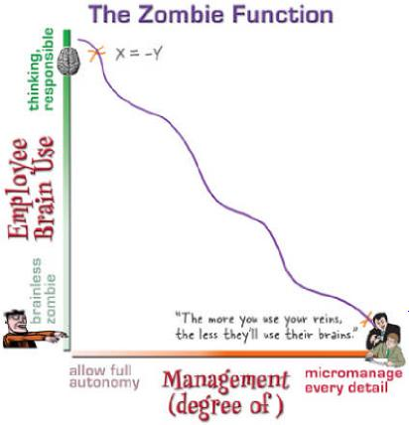
I think it may also be interesting and valuable to treat our students and ourselves the same way. That rather than graduating finished students, who are ready for the world, that we produce people who are raw material, capable of not only adapting to a rapidly changing world, but also able to continue to learn, unlearn, and relearn, so that they can shape that world into something that is better.
It's fun for these kids, no doubt, who are connected and self-motivated and have the equipment. They're learning, and they don't even know it. They're writing, producing, organizing, planning, editing, listening, dreaming, presenting and more. It's good stuff.
But I wonder how much further down the road they'll be able to run than the kids who aren't getting the chance to create and connect their own content either because they can't afford it or their schools can't see it.
When I think about this, I see amazing potential. But I also see a lot of kids getting left further and further behind. For too many, learning is still pre-packaged, and it will remain so for quite some time unless some major changes occur. The same holds true for educators who are unwilling to imagine what could be, much like the Oscar voters who couldn't bring themselves to see Brokeback Mountain because of the "unsettling" content (at least for them.)

I agree with George.
As educators, we are not grasping (or prepared for) the depth of the change that is occurring under our feet. If it's happened (breaking apart the center) in every other industry - movies, music, software, business - what makes us think that our educational structures are immune? And what does it mean to us? What should we be doing now to prepare our institutions? Ourselves? Our learners?
We should all be thinking about that.

MySpace now has 72 million users¹. That is larger than the populations of 213 countries². Perhaps we could deal with the social online networks thing if we thought of it for what it is — MyNation. This is their digital nation. They are citizens, and they’ve never been taught digital civics.

Let’s have a little competition at school and get ready for the future. I will use a laptop and you will use paper and pencil. Are you ready...?
- I can provide up-to-date information to my students - you have a textbook that is 5 years old.

- I can find and change all my instructional materials, worksheets, study guides, tests, every year you better hope the master is good enough for one more photocopy.

- I will model 21st century skills - technology, information-problem solving and life-long learning you will lecture about them.

- I will provide my visual learners an accessible means of grasping concepts through multimedia resources - you can use simpler words..

- I give my students a world-wide audience for their creative work – you will share your students' work with the class.

- I will give my students access to study materials and resources for my class 24/7 - you hope they remember to bring home the textbook.

- I will communicate with my students and parents electronically - you can hope to catch them after class or at home in the evenings.

- I will give parents real-time access to how their children are performing in my class - you send our report cards and have two parent-teacher conferences a year.

- I will use the information gathered from computer enabled value-added testing to know exactly what my individual students' strengths and weakness are - you will use whole group instruction.

- I will communicate with educational leaders and experts using email – you will try to remember the advice of the instructor in your college methods class from 1980.

- I will honor the variety of reading abilities of my students by providing materials on a topic at a variety of reading levels - you will use the basal reader.

- I will collaborate with my peers from around the world – you will stay behind your classroom door.

- I will allow my students to take their learning as far as they want – you must keep everyone at the same place at the same time.

- The cost of a laptop or tablet per year? Less than textbooks and workbooks.

- The cost of teacher training? – Expensive, but no more so than other staff development activities

- The cost of effective schools? - Priceless

Our problem is that we now live in a society that demands full literacy. The model of literacy that has driven schooling for the last many decades does a pretty good job of teaching sufficient numbers of students to consume content (read) and perform mathematical operations on a limited quantity of numbers (arithmetic). We were taught some writing, but the emphasis was on reading and math (NCLB).
Being able to function, contribute, and prosper in this new information environment — more conversation than library— requires full literacy, the ability to interact within that information environment in a way that adds value. It means expanding our notions of literacy beyond reading the text on the paper in front of you. It means being able to expose truth within the information that surrounds you. Students must learn to:
- Find information appropriate to their needs
- Decode the information regardless of its format or medium
- Evaluate the information in order to determine its value
- Organize valuable information into personal digital libraries
Full literacy goes way beyond being able to perform mathematical operations with a dozen numbers on a piece of paper. It means being able to employ information that can come as thousands of numbers, regardless of what they look like. They may be numbers. They may also be the bits and bytes of text, images, sound, animation, or video. We must know how to process all of this information to add value.
Communication is key to accomplishing almost any goal today, and communication goes way beyond being able to write a coherent paragraph. If students cannot express ideas compellingly with text, images, sound, animation, video, and any remixed combination of these, then that student is not literate.
Finally, full literacy happens only when information participants work within an ethical context that recognizes and puts into practice that it is we who must protect the information; it’s reliability, it’s ownership, and the infrastructure that it rides on.
We live in a time of rapid change, where we are faced with new questions, new problems, and new goals. We need the Wikipedia and this conversational web because the solutions to new situations do not necessarily come from credentialed authorities who owe their position to what they were taught ten years ago. New answers will come from something that somebody said yesterday, from her living room, on another continent. New answers and new solutions will come less from what we’ve been taught. Instead, they’ll come from our experiences, and our ability to reflect on those experiences, mix and remix them into something valuable, and contribute our conclusions and insights to our global neighbors.
In a time of rapid change, the measure of success depends more on how adaptive and inventive the learner is — their ability to turn instability into opportunity. In this world, summative testing makes no sense. I continue to maintain that when we cannot clearly predict our children’s future, it becomes much less important what they are learning, and much more important how they are learning it, and what they are doing with it.
Gulin said that the practices of innovative teachers are considered, “...untried and untrue because they don’t connect with the traditional environment of school.” I think that the real story is that our schools are not connecting to (relevant to) their own goals, preparing children for their future.
He goes on to say that change may not happen from within our schools, but as a result of the demands of society. I agree with this, and this idea may be helpful in responding to Darren Kuropatwa’s apparent struggle with what I mean by “telling the new story”. Actually, he seems to understand quite well what I mean. It’s the demands of that society and our children’s future that needs to be made into a story, and then told in compelling ways back to the community (and to communities of teachers). It requires that we observe, speculate, converse, and construct a compelling story that clearly defines what children need to be learning, and how they need to be learning it, and in what kinds of classrooms (or not) it should be happening in. That story has to connect to a market-place, to deeply held values, and it needs to be something that we can point to and say, “Isn’t that the kind of education your children deserve?”
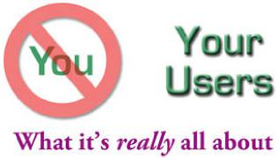

As part of a demonstration of podcasting, I recorded the teachers’ answers to this challenge: Imagine walking into your classroom in 2015 and describe what you see that wasn’t there in 2006.
Some of the resulting blog comments and independent blog reviews of the podcast surprised me. Several educators, whom I respect greatly, felt that many of the ideas expressed in the clips, and especially in my own vision, were too much to expect in the next decade — that funding, staff development, school structure, political will, and a number of other constraints will prevent us from making much change at all. At present, these educators have every right to expect little. After all, how much have classroom computers, Internet in every room, amazing instructional software, and other advancements really changed what teachers and students do in their classrooms?
I think, however, that the pessimism that all of us feel with regard to retooling our classrooms comes from asking the wrong question. Should we be asking...
What should we reasonably expect our education system to achieve in the next ten years? or should we ask...
What should today’s children reasonably expect from our education system over the next ten years?
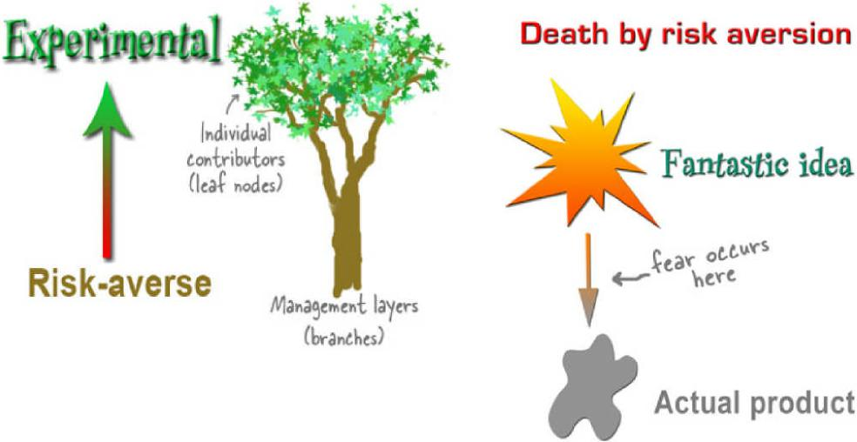

I think that our children have every reason to expect a lot more.

_____________________________________________________________________
On the plane out to San Diego I got the chance to watch Sir Ken Robinson’s great presentation at the TED conference (Technology Entertainment and Design). It’s a pretty powerful call to “radically rethink our view on intelligence” and “rethink the fundamental principles on which we are educating our children” to move toward a much more nurturing educational environment for the arts and for creativity. The money quote is
Creativity, now, is as important in education as literacy, and we should treat it with the same status.
Why? Because, as he points out, the kids who start school today will be retiring in the year 2065, and yet we know as little about what the world will look like then as we do five years from now. We can give them all the content we want, but in this age, it won’t make much difference if we don’t teach them how to learn first. And they do that not by spitting back at us what they “know.” They do it by being creative, by trying and failing, by succeeding and reflecting. It echoes Daniel Pink’s book all over.
George Siemens points to an interesting read in a similar vein in “How Failure Breeds Success” and says “learning is not a process of performance, it is a process of becoming.” And if we are lifelong learners, we are always becoming.
_________________________________________________________________
Our kids are connected. Technology is part of their lives. But let’s try to picture this in a different way. As you are, by now, accustomed to my saying, “It’s not technology, it’s information”. These gadgets are their links to information. They talk, text message, and Google with their mobile phones, IM on their laptops, access the world wide web, Net-based video games like Halo, MMORPG (did I get that right?) games like EverQuest and Second Life. These gadgets represent intellectual appendages to our children. They are the hands and feet that carry children to new experiences, and cutting these links is like cutting an appendage — and that makes no constructive sense to these children and their world view.
Yet we try to cut it off.
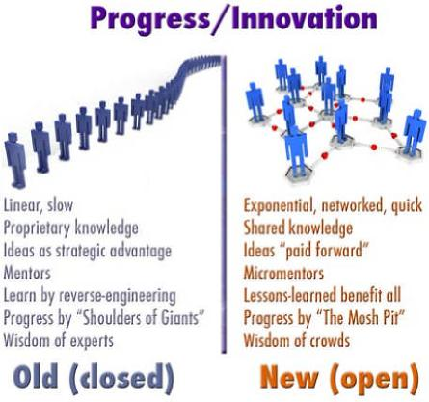

We ourselves have to do these types of activities no matter what happens to us, in spite of the consequences. What I think we're really getting at isn't that the tools are so powerful, but that we're disempowered as educators, and that those Web 2.0 tools (blogs, wikis) allow us to get that power back. But, it's a different kind of "power" than what we've been accustomed to as educators, but, I hope, not as educational technologists. This quote from Quinn really hits home, especially with the implications of what we must do:
To observe transformational capability, we cannot observe normal people doing normal things. We must observe people who are living by principle. To develop transformational capability, we cannot be normal people doing normal things. We must stand outside the norm. To do that we need to go inside ourselves and ask who we are, what we stand for, and what impact we really want to have. There we find the capacity not only to withstand the pressures of the external system, but also actually to transform the external system.
___________________________________________________________________
How should districts balance security, community/moral/standards, social networking, and emerging, disruptive technologies? - David Warlick
What will happen when information flows over the geographic obstacles and cultural barriers that have divided human beings into thousands of isolated groups for most of our history as a species? - Bruce E. Wexler
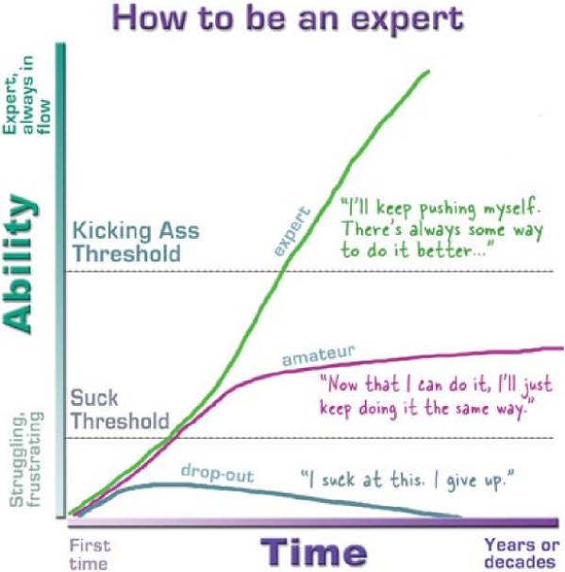

I was taking some time to think about educators who feel they are falling behind the kids in terms of what it means to be literate. Some are proposing that what we need to do is incrementally, but intensively, increase our skills until we, at some point in the future, are "caught back up" with where the kids are. The problem being of course that the literacy skills, and learning tools that kids are using these days are moving targets. As we edge up in our understanding of what they are doing, and what the possibilities are, the kids have left us behind again as they head off in another direction.
The definition of insanity is doing the same thing over and over again and expecting a different result each time. This, in some ways, seems to be where we are. We are starting see an ever - expanding gap between "school" literacies and literacies that kids "do" on their own. I come back again to the idea of underground digital apprenticeships. While we teach whatever we teach at school, the kids go home and learn the skills they need to survive and prosper in an inter connected global economy.
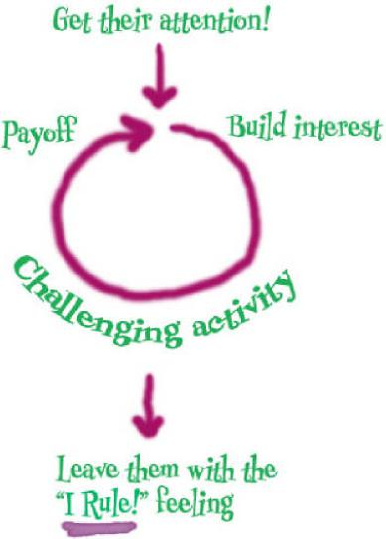
Hence, the need to leapfrog. Economists talk about leapfrogging when they look at nations in Africa and Asia that are making quick economic progress in communications, in connecting their people. While in North America and Europe, nations worked through a slow historical progression of sending telegrams, constructing a system of land - based telephone lines, and then moving into a cell - phone based system, developing nations are leaving the previous technologies behind and moving straight to cell - based systems allowing them to catch up quickly, connecting people across their nations. Now that MIT has brought out its $100 laptop, these nations will be on the same "playing field" as our kids very soon.
We need to develop this same idea in education. We need to leave behind ideas of incrementally increasing our understanding, and incrementally changing our teaching methods, slowly bringing people up to speed. This idea worked fine when ideas of literacy and education were not rapidly changing, but they are. We need to be able to leapfrog in our understandings, in our methods, and in our tools, allowing us to move to where the kids are. If we do not become leaders to our students, we will be followers, seen as irrelevant, and left to cry in our books while the kids are off setting the agenda.
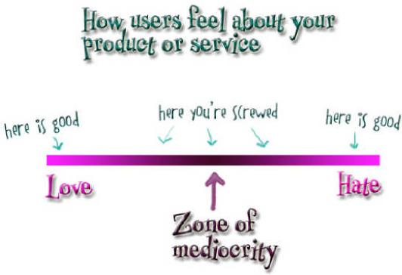

No one jumps a 20 foot chasm in two 10 foot jumps. – Miguel Guhlin
Most interesting to me is the question of the effectiveness of incrementalist approaches to change (as a comment notes: no one jumps a 20 foot gap with two 10-foot jumps). Clarence feels an urgency for change and has called for a leap-frog approach in attempting to catch up with students’ practices in new literacies.
Almost two years ago I presented to the Instructional Technology Specialists program group on this topic. My presentation was called “Incrementalism, Evolution, and Revolution.” My basic premise was that a) the academic world is incrementalist by nature and that this has worked (such as it has) because the underlying structures and assumptions for and by educators have remained the same and, b) things are no longer the same– technology and students (and the connections that tie them together in the form of social software and networks) are changing at rates never seen before. I even trotted out the parable of the frog in the beaker and the blind men describing the elephant.
The difference– I maintained then and continue now– is that this is not an attempt at change by well-meaning teachers but a revolution that is happening outside of our control, in our student population and there will be a tipping point in this process when the academy finds itself wholly inadequate and unsuitable to those they presume to serve... and no time to patch their outmoded mechanisms. I imagine the same shrill rage that will come when global-warming naysayers are finally forced to face the facts; it’s a sad satisfaction... too little, too late.
There’s an important matter of scale to be considered: one teacher’s incremental approach may be another’s revolutionary change. The same commenter who talked about being unable to bridge a 20 foot chasm in two jumps spoke shiningly of changing one classroom at a time. Is even that too little? Is there hope of anything else?
http://www.chrislott.org/2006/06/20/dead-teachers-and-tipping-points/ All pictures are from http://headrush.typepad.com unless otherwise noted.

It seems to me that in order to shape the application of new technologies, we need a mold to shape it around, and that mold needs to be new as well. One of our problems has been that we have tried to shape the technology around out-dated notions of what schooling is about, rather than reshaping our notions to reflect new world conditions.
So here is my basic list. Here’s what has changed, what is different.
1. The Information is different
- It’s Networked — Information is increasingly coming to us through networks, initially radio and TV, but today it comes to us over the Internet from nearly anywhere, from nearly anyone, and for nearly any reason

- It’s Digital — Information is now made of ones and zeros, and as a result, information can be reshaped in a wide variety of ways, using increasingly ubiquitous tools. We are starting to think of information as a raw material, not merely as a product to be consumed.

- It’s Overwhelming — Information is increasingly increasing. This is important because the messages that we wish to deliver to help us accomplish our goals, must compete for attention among all the other messages out there.

- It Doesn’t Need a Container — information is shaped differently. It cannot be contained nor controlled in the traditional sense. We must depend less on central gatekeepers to assure the information and more on our own skills and highly developed sense of ethics when accessing, using, and producing information.
Each of these aspects of information leads to a dramatic expansion of what it means to be literate, the new BASICS of school curriculum.
- Content is Different — The answers to today’s questions will not be their answers tomorrow. Science, health, culture, politics, economics, and even history are all changing. In a rapidly changing world, it becomes much less valuable to be able to memorize the answer, and much more valuable to be able to find and even invent the answers.

- Our Tools are Changing — Technology is changing at dizzying rates, which is part of the reason for the preceding elements of change, but also a good reason why we should be focused on the information and not the technology. We can’t keep up with making the technology the curriculum. All we can do is prepare our students to teach themselves. It’s the only way to keep up.
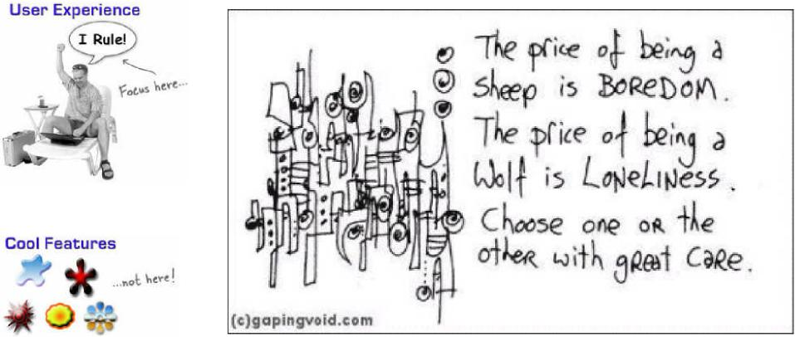

Conversations continue about schools that block access to the blogosphere. I ran across an interesting comment last night, in my end of the day aggregator scan. It was in a blog post by Wesley Fryer (Censored for Relevance - April 11, 2006), that he said, “Are we living in the United States here, or totalitarian China?”
There are distinct differences between censorship in China and censorship in the U.S. In China, it is the government that is in a position of power, whereas, in the U.S. it is individuals and the mobs that they form that owns the power. But Fryer’s statement, I believe, is still a fair association. In both cases, censorship happens from the government’s fear of the people. China fears access to information that empowers people to challenge their authority. In the U.S. we fear challenge to the government’s ethicacy.
But the pivot point is not politics. It’s in the desperate belief that we can contain the information. It’s in our gatekeeper insistence that the information we do not want our children to have can be put on the highest shelves, hidden in the back of a closet, hidden within a brown paper wrapper, or rejected by editors and librarians,
The awful shame of it is that we have, as a result, convinced our children that their information is safe inside of their containers. Find your child’s MySpace writings and then question them. They will say, “That wasn’t for you.” “What are you doing in my space?” “How did you find that?” “How did you get there?” “I thought I was protected.” “I thought my information was containered for me and my friends.”
Because we still treat information as something that we can hide behind a wall, and we continue to teach that way to our children, they do not realize the dangers that their information represents to their personal safety and future well being.
Perhaps, we should stop thinking about the problem as something that we can cut off, like amputating a gangrenous arm. Instead, why not think of it as something that is integral to our culture — and treat it.
I’m getting tired of hearing people continue to ask for the evidence that technology helps students learn. It doesn’t matter. We know — that good teachers help students learn. We need technology in every classroom and in every student and teacher’s hand, because it is the pen and paper of our time, and it is the lens through which we experience much of our world.

Calendar for year 2011 (Malaysia)
October |  | November |  | December
Mo Tu We Th Fr Sa Su  1 2  3 4 5 6 7 8 9  10 11 12 13 14 15 16  17 18 19 20 21 22 23  24 25 26 27 28 29 30  31 |  | Mo Tu We Th Fr Sa Su  1 2 3 4 5 6  7 8 9 10 11 12 13  14 15 16 17 18 19 20  21 22 23 24 25 26 27  28 29 30 |  | Mo Tu We Th Fr Sa Su  1 2 3 4  5 6 7 8 9 10 11  12 13 14 15 16 17 18  19 20 21 22 23 24 25  26 27 28 29 30 31
4: 12: 20: 27: |  | 3: 11: 18: 25: |  | 2: 10: 18: 25:

Holidays and Observances:
26 Oct | Deepavali
7 Nov | Hari Raya Haji
27 Nov | Muharram/New Year
24 Dec | Christmas Eve
25 Dec | Christmas Day
26 Dec | 'Christmas Day' observed
31 Dec | New Year's Eve

Calendar for year 2012 (Malaysia)
January |  | February |  | March
Mo Tu We Th Fr Sa Su  1  2 3 4 5 6 7 8  9 10 11 12 13 14 15  16 17 18 19 20 21 22  23 24 25 26 27 28 29  30 31 |  | Mo Tu We Th Fr Sa Su  1 2 3 4 5  6 7 8 9 10 11 12  13 14 15 16 17 18 19  20 21 22 23 24 25 26  27 28 29 |  | Mo Tu We Th Fr Sa Su  1 2 3 4  5 6 7 8 9 10 11  12 13 14 15 16 17 18  19 20 21 22 23 24 25  26 27 28 29 30 31
1: 9: 16: 23: 31: |  | 8: 15: 22: |  | 1: 8: 15: 22: 31:
April |  | May |  | June
Mo Tu We Th Fr Sa Su  1  2 3 4 5 6 7 8  9 10 11 12 13 14 15  16 17 18 19 20 21 22  23 24 25 26 27 28 29  30 |  | Mo Tu We Th Fr Sa Su  1 2 3 4 5 6  7 8 9 10 11 12 13  14 15 16 17 18 19 20  21 22 23 24 25 26 27  28 29 30 31 |  | Mo Tu We Th Fr Sa Su  1 2 3  4 5 6 7 8 9 10  11 12 13 14 15 16 17  18 19 20 21 22 23 24  25 26 27 28 29 30
7: 13: 21: 29: |  | 6: 13: 21: 29: |  | 4: 11: 19: 27:

July |  | August |  | September
Mo Tu We Th Fr Sa Su  1  2 3 4 5 6 7 8  9 10 11 12 13 14 15  16 17 18 19 20 21 22  23 24 25 26 27 28 29  30 31 |  | Mo Tu We Th Fr Sa Su  1 2 3 4 5  6 7 8 9 10 11 12  13 14 15 16 17 18 19  20 21 22 23 24 25 26  27 28 29 30 31 |  | Mo Tu We Th Fr Sa Su  1 2  3 4 5 6 7 8 9  10 11 12 13 14 15 16  17 18 19 20 21 22 23  24 25 26 27 28 29 30
4: 11: 19: 26: |  | 2: 10: 17: 24: 31: |  | 8: 16: 23: 30:
October |  | November |  | December
Mo Tu We Th Fr Sa Su  1 2 3 4 5 6 7  8 9 10 11 12 13 14  15 16 17 18 19 20 21  22 23 24 25 26 27 28  29 30 31 |  | Mo Tu We Th Fr Sa Su  1 2 3 4  5 6 7 8 9 10 11  12 13 14 15 16 17 18  19 20 21 22 23 24 25  26 27 28 29 30 |  | Mo Tu We Th Fr Sa Su  1 2  3 4 5 6 7 8 9  10 11 12 13 14 15 16  17 18 19 20 21 22 23  24 25 26 27 28 29 30  31
8: 15: 22: 30: |  | 7: 14: 20: 28: |  | 6: 13: 20: 28:

Holidays and Observances:
1 Jan New Year's Day  2 Jan 'New Year's Day' observed  23 Jan Chinese Lunar New Year's Day  24 Jan Second day of Chinese Lunar New Year  1 Feb Federal Territory Day  5 Feb The Prophet Muhammad's Birthday  1 May Labour Day  2 Jun The Yang di-Pertuan Agong's Birthday  19 Aug Hari Raya Puasa Day 1 |  |  | 20 Aug Hari Raya Puasa Day 2  31 Aug National Day  16 Sep Malaysia Day  26 Oct Hari Raya Haji  13 Nov Deepavali  15 Nov Muharram/New Year  24 Dec Christmas Eve  25 Dec Christmas Day  31 Dec New Year's Eve

http://ithinkmalaysia.weebly.com/classrooms-in-malaysia.html
Datuk Dr Kamal Jit Singh, Thinking – the Basis of Innovation, February 6, 2011.
Border, Pete. Pete Border taught physics at the university level, and was involved with 4 PBL-based courses, three of which he designed. One is a class on “Visualizing Physics” at MCAD (a local Art School) and the other three are classes in the UMN Physics Department (Freshman Seminar on “Physics for Game Designers”, an online class on Game Design, and the labs for their Honors Physics sections). Also see - Peter M. Border, a physics instructor in the School of Physics and Astronomy at the University of Minnesota reported on an experimental physics class which taught elementary mechanics by having students design computer games. The students learned physics by programming agents to move, roll, and collide in a physically correct manner, which required them to understand the physics behind the motion. The students created approximately one videogame each week and even though students needed to learn the programming associated with making videogames, the instructor was able to cover the material of a typical first-year physics class. Student engagement and learning was reported to be very high. (From NASA’s Advanced Technology Applications for Education Benchmark Study http://learn.arc.nasa.gov/benchmark/4.1.html )
McLeod, Scott. Thought Sparkers. 2006. Scott McLeod, Ph.D. is Associate Professor of Educational Leadership at the University of Kentucky, USA. He is also the founding director of CASTLE and creator of the popular video series Did You Know? Thought Sparkers doc with original graphics is no longer online.
Datuk Dr. Kamal Jit Singh, The Future is Now, interview with Zakia Koya, 2011. http://www.malaysiainovatif.gov.my/index.php?option=com_content&view=article&id=254%3Athe-future-is-now&catid=58%3Aberita-terkini&Itemid=88&lang=
Datuk Dr Kamal Jit Singh, TOTS the first tool, April 24, 2006
Document no: 0129061101, Innovating Malaysia – a Joint Effort by MOSTI & AIM, National Innovation Policy, p. 4
Ibid.
Wagner, Tony. The Global Achievement Gap: Why Even Our Best Schools Don't Teach the New Survival Skills Our Children Need--and What We Can Do About It , Basic Books, 2010
http://ithinkmalaysia.weebly.com/classrooms-in-malaysia.html
Darling-Hammond, Linda. What we can learn from Finland’s successful school reform, Teachers College Press, 2010.
Kellner, Douglas, Ph.D., New Media and New Literacies – Reconstructing Education for the New Millennium. Dr. Kellner is a member of the Advisory Board for 21st Century Schools, and is the George F. Kneller Philosophy of Education Chair, Division of Social Sciences & Comparative Education, Graduate School of Education & Information Studies, UCLA.

